Module:-COSA(Concept Of Operating System And Administration) Date:- 21/10/2022
Assignment :- 02(Installation of Kali Linux) Name:- Prauthviraj Nikam

Step 1:- Firt of all download Kali Linux from following website.
https://www.kali.org/get-kali/#kali-installer-images

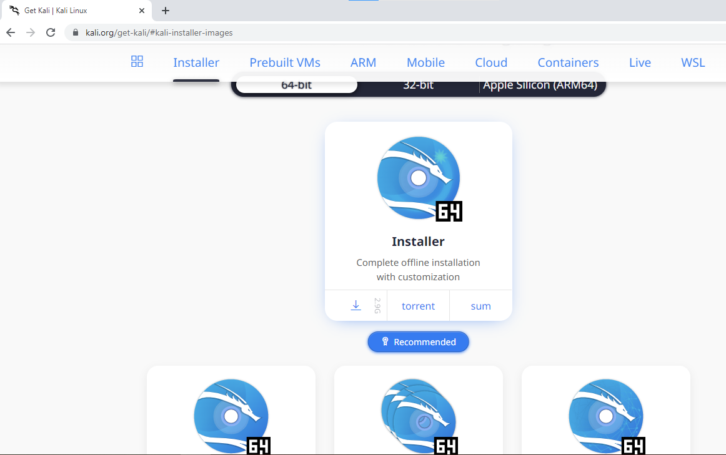

Step2:-Open virtual box and Create New Virtual Machine Using NamKaliLinux_Prithviraj

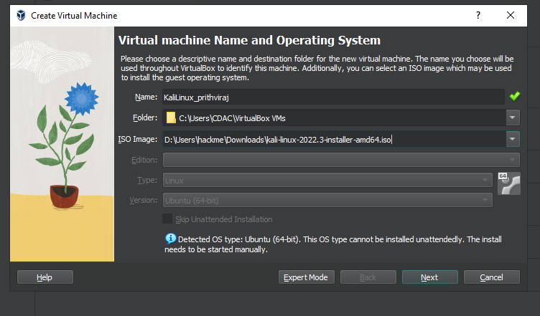
Step 3:- Now put Base Memory(RAM) = 2048 MB and Processors = 1CPU

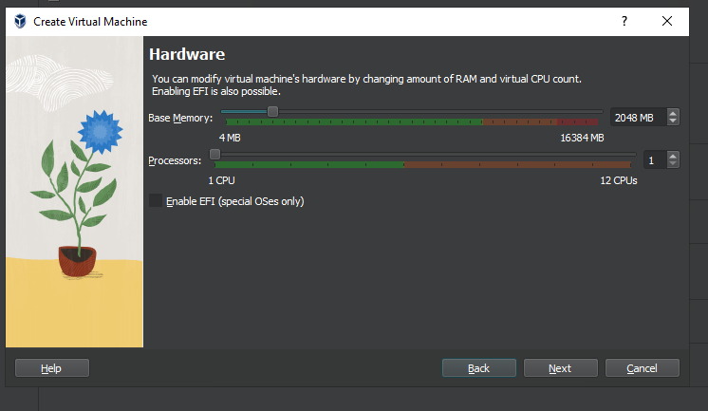

Step 4:- Now Put Storage = 31.12 GB
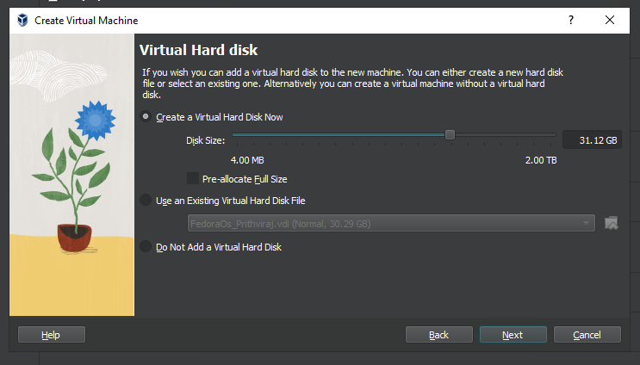

Step 5:-Now go to setting Select Network Bridge Adapter and Storage Controller IDE

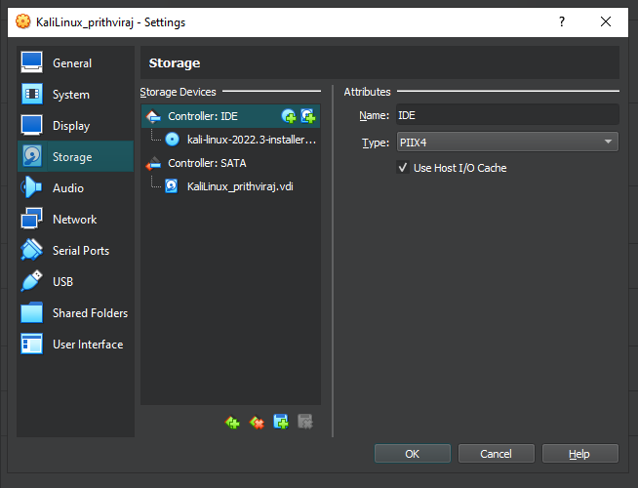

Step 6:-Click the run symbol and Configure Network of kali linux.

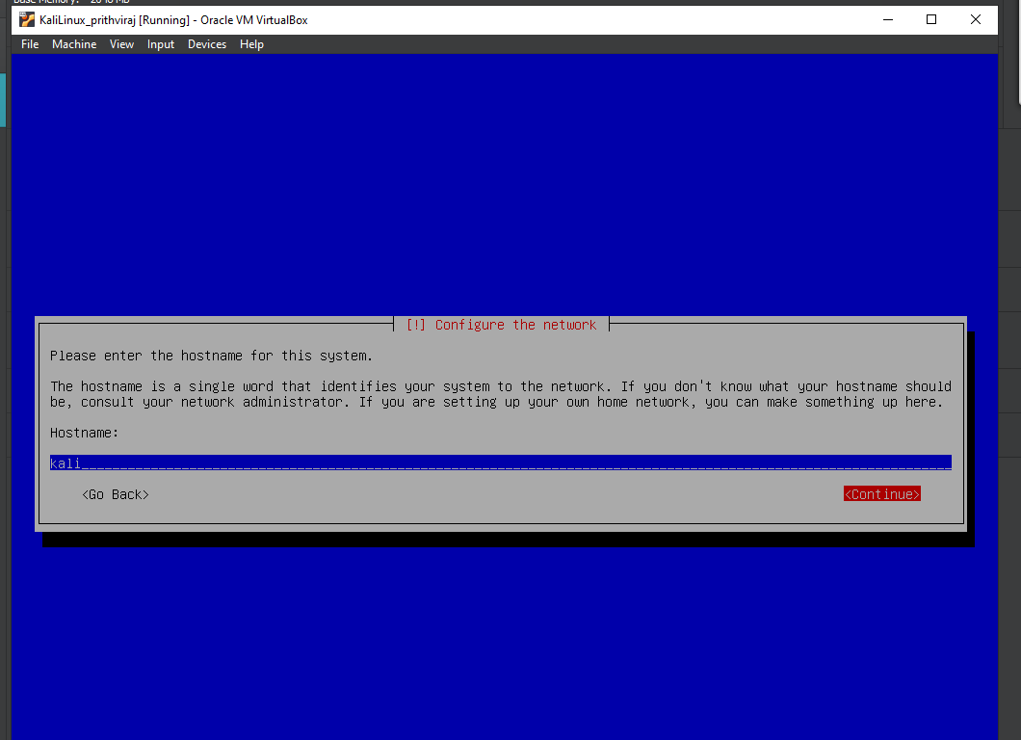

Step 7:- Now Set User Full Nmae = Prithviraj username = prithvi and Password = ****** and last after this process finish the partition.

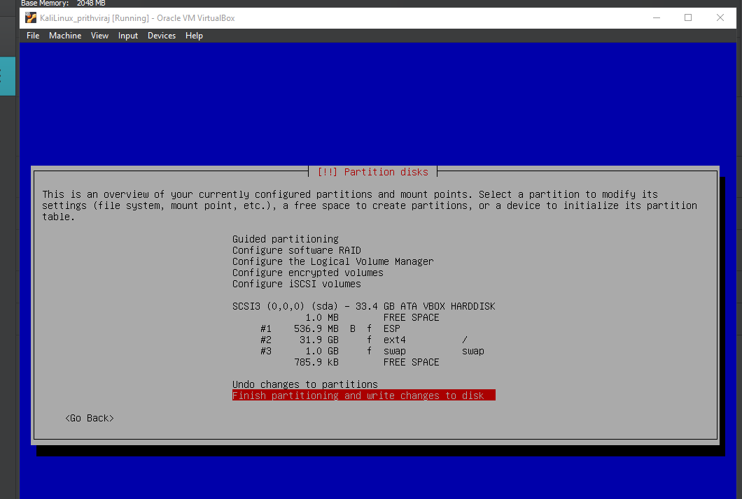

Step 8:-Now Install the software.
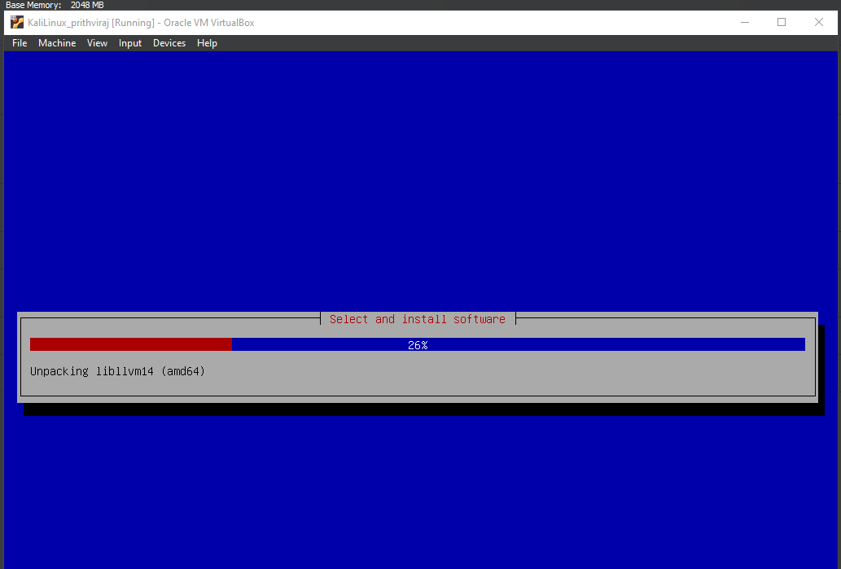

Step 9:-After completion of Installation open new Kali Linux GUI Window.
